Robust Real-Time Spectral Tracking in Single and Multilayer Porous Thin Films for Continuous Optical Biosensing
P. Sharma^{1,2}, C. Zhang¹, N.H. Voelcker^{1,2,3*}
¹Drug Delivery, Disposition and Dynamics, Monash Institute of Pharmaceutical Sciences, Monash University, Parkville, Victoria 3052, Australia.
²Melbourne Centre for Nanofabrication, Victorian Node of the Australian National Fabrication Facility, Clayton, Victoria 3168, Australia.
³Materials Science and Engineering, Monash University, Clayton, Victoria 3168, Australia.
*Corresponding author

Abstract
Optical reflectance-based biosensors using porous structures have emerged as a versatile label-free platform for real-time continuous biomolecular detection, owing to their tunable nanostructure, large internal surface area, and compatibility with broadband white-light readout. However, despite significant advances in these photonic biosensors, no existing analytical method simultaneously delivers instantaneous signal extraction without dedicated computational infrastructure, reliable performance in terms of sensitivity and selectivity across both single-layer (SL) and multilayer (ML) architectures, and robust signal tracking in complex biological matrices, capabilities that are collectively essential for point-of-care (POC), wearable, and implantable biosensing applications. Here, we introduce and systematically evaluate the effective shift in wavelength (ESW) method as a computationally minimal method that can be extended to different photonic architectures. By computing the ratio of reflectance intensities at a wavelength corresponding to a well-defined minima or maxima and the immediately adjacent longer wavelength, separated from the reflectance minima wavelength by a single spectrometer pixel, ESW generates a dimensionless parameter that is inherently robust to amplitude variations and signal offsets and requires no Fourier transforms, wavelet convolutions, or phase-unwrapping operations. We benchmark ESW against conventional Effective optical thickness (EOT) method as well as more recently introduced Interferogram averaged over wavelength (IAW) and Morlet wavelet phase (MWP) methods across five performance metrics: analytical sensitivity, selectivity, baseline noise, computation time, and applicability to multiple architectures using both SL and ML porous silicon (pSi) structures. ESW delivered the lowest limit of detection (LOD, 45 nM for an insulin aptasensor), superior long-term stability, instantaneous real-time output, and unique cross-architecture applicability across Fabry-Pérot, microcavity, and Bragg mirror-based pSi structures, capabilities that existing methods including the current state-of-the-art MWP cannot simultaneously achieve. We further demonstrate reliable, artefact-free ESW performance in undiluted human serum and successful real-time specific insulin detection by an implanted pSi microcavity aptasensor in ex vivo mice model.

Keywords
Porous silicon, EOT, IAW, MWP, interferometric reflectance spectroscopy, RIFT, biosensors, biofouling, wearables, implantable

Introduction
Data analysis is a critical yet often overlooked component of optical biosensor design as it directly influences the achievable LOD by enabling reliable discrimination of true analytical signals from measurement noise and non-specific response in a complex biological matrix.^{1,2} Accurate quantification requires a sufficiently high signal-to-noise ratio, ensuring that the measured response is statistically distinguishable from baseline fluctuations. Consequently, numerous quantitative signal-processing approaches have been developed to improve detection sensitivity and reduce the influence of noise.^{2–4} The performance of these methods depends not only on the statistical confidence of the extracted signal but also on their ability to identify clear response while minimizing false positives. In addition to sensitivity, factors such as selectivity, computational infrastructure and complexity, and processing time determine the suitability of a given analysis method. These considerations are particularly important for real-time and continuous biosensing applications, where rapid, robust, and reliable interpretation of the sensor data is essential.
In the context of optical biosensing, interferometric reflectance spectroscopy (IRS), has emerged as a powerful label-free technique for monitoring biomolecular interactions within nanostructured porous layers including porous silicon (pSi), nanoporous anodic alumina (NAA) and porous titanium oxide (TiO₂).^{5–7} The sensing mechanism relies on changes in the effective optical thickness of the porous layer upon analyte infiltration and binding, which modulate the reflectance spectrum through Fabry-Pérot interference effects as shown in Figure 1(A(i)-C(i)). Accurate extraction of these spectral changes either as a shift in fringe position or phase, or modulation of reflectance intensity at resonance features is therefore critical for achieving high sensitivity and reliable quantification, particularly at low analyte concentrations and in complex biological matrices.^{8,9} The choice of signal processing method directly determines which of these spectral parameters is interrogated, and consequently governs the achievable LOD, noise robustness, and suitability for real-time deployment.
Among the signal processing approaches developed for pSi IRS based biosensor, the effective optical thickness (EOT) method extracted using reflective interferometric Fourier transform spectroscopy (RIFTS), is the conventional and most widely used approach for analyzing the IRS spectrum.¹⁰ It involves transforming the reflectance spectrum into the Fourier domain and tracking the position of the dominant peak corresponding to the optical thickness (2nL, where n is the effective refractive index and L is the physical thickness) of the film. Despite its simplicity and computational efficiency, the EOT method is susceptible to elevated baseline noise that limits its sensitivity at low analyte concentrations, where the true binding signal becomes statistically indistinguishable from measurement fluctuations. The reliance of this method on the Fourier peak position renders it vulnerability to linearly varying spectral offset in complex media, where slowly varying baseline distortions from protein scattering and wavelength-dependent absorption displace the dominant Fourier peak independently of any true analyte-induced optical thickness change.¹¹
To address the noise limited sensitivity of the EOT method, Mariani and co-workers introduced the interferogram average over wavelength (IAW) method as an alternative signal processing approach improving the LOD by four orders of magnitude as compared to EOT method.¹² By integrating or averaging spectral features, IAW can enhance the detection of small changes compared to EOT. IAW operates directly on the spectral interferogram by removing the slowly varying reflectance envelope through baseline or reference subtraction. The sensing signal is computed as the average value of this interferogram across the measured wavelength range, and changes in this averaged quantity upon analyte binding constitute the sensogram output.^{12,13} However, IAW is inherently sensitive to changes in reflectance intensity and signal offset in addition to wavelength shifts, meaning that broadband intensity variations arising from optical drift, or nonspecific adsorption in complex matrices can generate artifactual responses indistinguishable from true binding signals. Furthermore, post-processing after spectra acquisition is required for baseline subtraction and spectral averaging steps affecting the computation time and infrastructure for real-time continuous operation.
More recently, Ward et al. introduced the MWP method that applies a complex Morlet wavelet convolution to the Fabry-Pérot interference fringes of the reflectance spectrum, which acts as a precise narrowband bandpass filter centered on the dominant fringe frequency, effectively suppressing both broadband white noise and low-frequency reflectance variations simultaneously.¹¹ The sensing signal is then extracted as the average difference in the unwrapped phase between the wavelet-filtered analyte and reference spectra. Because MWP interrogates the phase of the filtered interferogram rather than its amplitude, it is inherently insensitive to intensity variations that compromise IAW including optical drift, lamp fluctuations, and bulk refractive index changes upon solution switching making it significantly more robust in complex biological matrices.¹¹ The method showed one order of magnitude lower LOD for a BSA protein assay as compared to EOT and IAW methods and reliable detection of Anterior Gradient 2 (AGR2) protein spiked in 50% neat plasma establishing it as the current state-of-the-art signal processing method for reliable pSi interferometric biosensing.
Despite the demonstrated sensitivity improvements offered by advanced signal processing approaches such as IAW and MWP, their adoption within the broader pSi biosensor community remains limited. This is primarily because both methods rely on offline post-processing of acquired spectra and do not enable intrinsic real-time signal extraction during measurements using currently available commercial spectrometer software platforms (e.g., Ocean Optics SpectraSuite or OceanView). Most importantly, IAW lacks molecular specificity and exhibits substantial responses to non-specific interactions and false-positive signals, limiting its reliability for accurate analyte detection. Although undoubtedly, MWP provides improved signal-to-noise ratio and enables more reliable detection, its practical advantage remains limited because for many pSi sensor platforms, the final sensing outputs obtained using MWP are comparable to conventional EOT-based analysis as observed with the above mentioned AGR2 detection example.¹¹ Moreover, MWP's multi-step computational pipeline, encompassing Fourier transformation, wavelet convolution, and phase unwrapping demands significant processing, increasing the computation time and the requirement for sophisticated infrastructure limiting its practical applicability to continuous real-time monitoring contexts where rapid, on-the-fly signal interpretation is essential.
Additionally, all these methods have been designed and validated exclusively on SL Fabry-Pérot porous thin films, and their performance on ML photonic architectures where multiple closely spaced Fourier components can cause discontinuous phase transitions has not been systematically established. Conventionally, in ML structures (Figure 1(A(ii)-C(ii))) such as microcavities or rugate filter, the shift in the characteristic wavelength (either a maxima or minima) is tracked over time.¹⁴ However, the sensitivity or the minimum shift that can be detected is dependent on the wavelength resolution of the spectrometer .^{13,15}
To address these gaps in the current data processing methods applied across different porous architectures, we introduce the ESW method and systematically benchmark it against EOT, IAW, and MWP across five performance metrics sensitivity, baseline noise, computation time, selectivity, and structural applicability on SL Fabry-Pérot films and more complex ML microcavity and Bragg mirror-based structures. To our knowledge, this represents the first systematic comparison of all currently available signal processing methods across both SL and ML pSi architectures, and the first demonstration of a processing method capable of reliable performance across those architectures, and one that can be embedded directly into the current state-of-art acquisition systems.
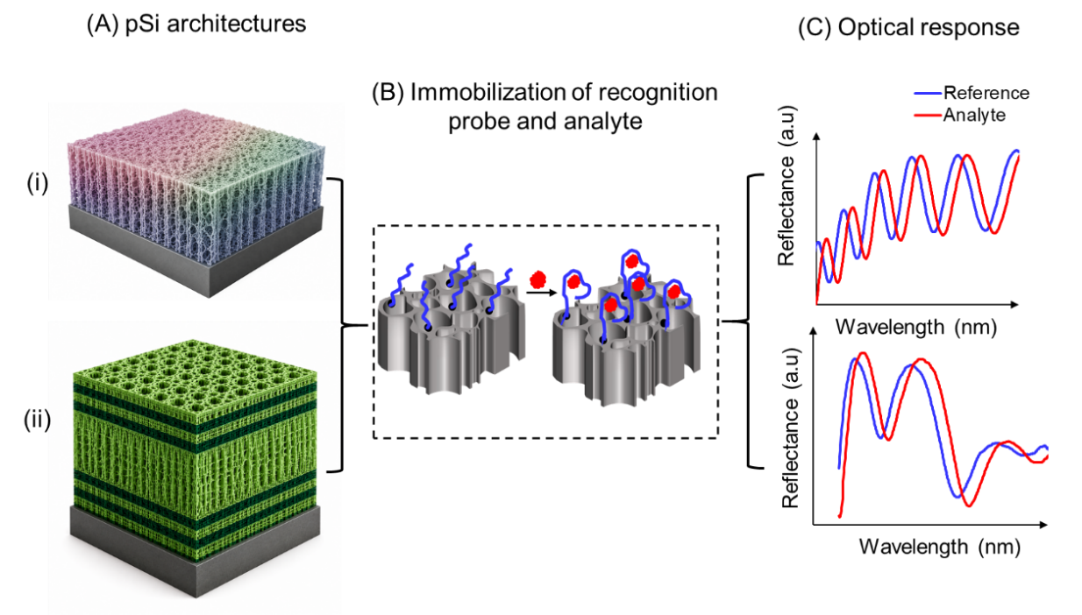
Figure 1. pSi optical biosensing platform. (A) Architectures of pSi photonic structures (i) SL ; (ii) ML showing a microcavity enclosed by two Bragg mirrors; (B) immobilization of biorecognition probe (aptamer) and binding with the analyte; (C) shift in the reflectance spectrum after binding of the analyte with the bioreceptor probe in (i) SL; (ii) ML architectures.

EXPERIMENTAL SECTION

Materials
Boron doped p-type silicon wafers ((100)-orientated, resistivity<1.5 mΩ cm, diameter 6″ and thickness ~500 μm) were purchased from Micro Materials (Australia). The 5’NH₂-modified insulin-binding aptamer (/5AmMC6/GG TGG TGG GGG GGG TTG GTA GGG TGT CTT C) as a lyophilized powder with HPLC-purification grade were obtained from Integrated DNA Technology (Australia). Remaining reagents were purchased from Sigma Aldrich (Australia) unless otherwise stated.

Fabrication and surface functionalization

Fabrication of pSiSL and PSiML architectures
The SL and ML pSi structures were fabricated using Boron doped p-type silicon wafers ((100)-orientated, resistivity<1.5 mΩ cm, diameter 6″ and thickness ~500 μm) using AMMT’s pSi etching system with 1:1 HF:ethanol solution. For all the structures, a sacrificial layer was first etched at 180 mA/cm² in 1:1 HF/ethanol electrolyte for 20 s, and subsequently removed in 0.1 M NaOH, washed in ethanol and deionized (DI) water, and dried under N₂ stream. The etch current and etching rate were tailored to fabricate pSiSL and pSiML structures. pSiSL were fabricated by using a current density of 77mA/cm² for 80 s. pSiML microcavities with (HL)₇HH(LH)₇ (where H represents the high porosity layer and L is the low porosity layer) structural profile were fabricated using a current density of 77mA/cm² for 10 s and 8 mA/cm² for 50 s for high and low porosity layers respectively. For the Bragg mirror, the same conditions as used to fabricate the Bragg reflector in the pSiML microcavity were used.

Thermally oxidized pSi
After fabrication pSi structures both SL and ML were thermally oxidized at 800 ˚C in a tubular furnace for 1 h to improve the stability of the structures in buffer.

Thermally hydrocarbonized pSiSL (THC-pSiSL)
Freshly etched pSiSL films were thermally hydrocarbonized using a mixture of acetylene and nitrogen (1:1) at 525 ˚C for 30 min in a tubular furnace. Before heating, the samples were purged under nitrogen flow for 45 min at RT. Acetylene was then introduced for 15 min at RT followed by heating at 525 ˚C for another 15 min.

Polymer-coated pSiSL (P1-pSiSL)
As-fabricated pSiSL films were coated with 1,4-naphthoquinone (100 mM in DMF) at RT for 2 h to obtain a phenolic surface (NQ-pSiSL) to support the controlled growth of Novolac resin (NR). For the NR coating, a suspension of p-toluenesulfonic acid (pTSA•H₂O, 456 mg), 4-tertbutylphenol (7.2 g, 48 mmol) and paraformaldehyde powder (1.5 g, 50.4 mmol for formaldehyde unit) in dioxane (12 mL) was heated at 95 ˚C for 5 min while stirring vigorously. NQ-pSiSL was then added to this solution for 30 min. After 30 min, the samples were cooled to RT, washed with acetone and dried under nitrogen flow (NR-pSiSL). For crosslinking (xNR-pSiSL), NR-pSiSL were added to a Schlenk tube containing a solution of methylene diphenyl diisocyanate (MDI, 250 mg, 1 mmol, 100 mM) in dry DMF (10 mL) under nitrogen flow, followed by addition of triethylamine (Et₃N, 14 µL, 0.1 mmol). The mixture was kept at RT for 3 h followed by 80 ˚C overnight heating. After washing with DMF and acetone thoroughly, xNR-pSiSL were obtained with the NR attached on the surface crosslinked to form an insulation layer and support subsequent functionalization of hydrophilic polymers.
xNR-pSiSL were added to a solution of N,N-dimethylacrylamide (DMAm, 1.8 g, 18 mmol), acrylic acid (AA, 144 mg, 2 mmol) and benzoyl peroxide (PBO, containing 25% H₂O, 64 mg, 1 mol%) in DMF (5 mL) at RT. The mixture was degassed under vacuum for 5 min before nitrogen was filled back. The reaction was sealed and heated at 80 ºC for 4 hours to obtain P1-pSiSL with hydrophilic poly(N,N-dimethylacrylamide-co-acrylic acid) (P(DMAm-co-AA)) antifouling layer attached on the surface.

Aptamer-functionalized pSiSL for insulin detection (P1-pSiSL-APT)
The hydrophilic co-polymer P(DMAm-co-AA)-functionalized samples P1-pSiSL were submerged in DMF (10 mL) and HATU (O-(7-azabenzotriazol-1-yl)-N,N,N',N'-tetramethyluronium hexafluorophosphate) (380 mg, 1 mmol) and 1-(3-aminopropyl)-1H-pyrrole-2,5-dione trifluoroacetate salt (125 mg, 0.5 mmol) were added to the mixture. After 1 h, triethylamine (280 µL, 2 mmol) was added. The reaction was then continued overnight at RT. The samples were washed with DMF, acetone and dried under a flow of nitrogen gas to obtain P1-pSiSL-Mal with maleimide attached for aptamer conjugation via thiol-ene click reaction.
Traut’s reagent (1.4 mg/mL) and tris(2-carboxyethyl)phosphine (TCEP, 2.9 mg/mL) were dissolved in water (10 mM each). Amine modified insulin binding aptamer (300 µL, 10 µM) , was added to Traut’s reagent (2 µL) and TCEP (2 µL) (each ~6 molar equiv.). The mixture was incubated at RT for 30 min to convert the amine to a thiol group. P1-pSiSL-Mal were then incubated in this solution at RT for 2 h for immobilization of the thiol modified aptamer. The samples were then washed with water and dried under nitrogen flow.

Aptamer-functionalized pSiML for insulin detection (pSiML-APT)
Thermally oxidized pSiML structures were subsequently treated with 5% 3-aminopropyl trimethoxysilane (APTMS) in anhydrous toluene under N₂ flow for 1 h. The ML structures were then rinsed thoroughly in toluene and ethanol 3-5 times to remove unreacted APTMS. Subsequently, the samples were heated on a hotplate at 110 ˚C for 10 min. The samples were then cooled down to room temperature and incubated in glutaraldehyde (10% in phosphate-buffered saline (PBS) at pH 7.4) for 1 h. The ML structures were then thoroughly rinsed in PBS and further incubated in insulin-binding aptamers (10 μM) in PBS overnight at 4 ˚C. Before incubation, the aptamer was heated at 95˚C for 5 min. The next day, the aptamer immobilized ML structures were washed in PBS to remove additional unconjugated aptamers on the surface. To prevent non-specific binding, the samples were incubated in 1 mg/mL of bis-PEG amine for 1 h.

Immobilization of Protein-A for detection of IgG (pSiSL-PA)
THC-pSiSL films were treated with undecanoic acid at 110 ˚C in N₂ overnight to attach carboxylic acid groups. The films were then rinsed thoroughly in ethanol and subsequently dried under nitrogen. The carboxylic group were activated using a 1:1 mixture of EDC (10 mg/mL) and NHS (5 mg/mL) in MES buffer at pH~5.5 for 1 h to form NHS ester. The samples were then rinsed in the buffer and dried under nitrogen. The EDC/NHS activated pSiSL were incubated in Protein-A for 1 h.

Optical sensing experiment
All the sensing experiments were conducted strictly in a plexiglass flow cell under static flow conditions. A halogen-tungsten lamp (HL-2000) from Ocean Optics was used as a light source. The light from the source through a bifurcated fiber optic cable was incident normally with a spot size of ~1 mm² on to the sample and the reflected light was collected through the same fiber using an Ocean Optics spectrometer. For SL films, UV-VIS (USB HR2000+ES) spectrometer was used with boxcar width 10, averaging 100 unless specifically mentioned, and spectral wavelength resolution of ~ 0.4 nm. For ML, NIRQuest+1.7 spectrometer with a resolution of 1.5 nm, boxcar width 10, spectral averaging~10 was used. All the experiments reported in this work were strictly performed in a flow cell to avoid errors due to position variation and height of the solvent in buffer. For all the sensing experiment, first a baseline was obtained followed by introducing the analyte and a final buffer wash. The reflectance spectra were measured under static flow.

Data analysis
The EOT method was evaluated using IGOR software, while IAW, and MWP were implemented using MATLAB. ESW can be directly obtained from the spectra suite software. For, ESW-filtered a MATLAB code was developed to read the reflectance spectrum, calculate ESW and apply SG filtering. All signal processing methods were evaluated over a consistent spectral window of 500–800 nm for pSiSL structures. For pSiML architectures, the spectral window was extended to 900–1700 nm to fully encompass the different characteristics of the ML.

Experiments using human serum
Undiluted human serum obtained from Sigma Aldrich (Australia) was used to evaluate the performance of the pSiSL structures to an oxidized and antifouling coated (P1-pSiSL) surface. The optical experiments involved a baseline in PBS buffer (pH~7.4) followed by addition of serum and a final buffer wash.

Ex vivo implantation of the biosensor
For ex vivo implantation of the biosensor, 12-week-old euthanized mice were obtained from the Monash University Research Platform (MARP). Before implantation of the biosensor, the hair on the dorsal side of the mouse was shaved off using a hair removal cream (Nair) and thoroughly washed with Milli-Q water afterwards. A small incision was then made using a scalpel and the biosensor was then implanted.

Results and Discussion

Effective shift in wavelength (ESW) method:

Porous silicon single layer (pSiSL) films
In reflectance-based (both SL and ML) optical biosensors, the sensing modality is the change in effective refractive index (n) of the porous layer upon analyte binding. As target analyte molecules adsorb onto internal pore walls, the refractive index increases directly increasing the EOT (EOT = 2nL, where L is physical thickness) and shifting the fringe pattern towards longer wavelengths. True analyte binding is therefore encoded as a shift in fringe position or wavelength, while the physical layer thickness L generally remains constant. Changes in fringe amplitude (peak to peak variation) or slowly varying spectral offset (complete upward or downward shift in the spectrum, reflectance spectrum with a fixed amplitude shift and spectral offset are depicted in Figure S1 in the Supporting Information) without an accompanying wavelength shift do not arise from the binding mechanism and represent spurious noise contributions¹⁶. An exception applies to large analytes such as bacteria, whose dimensions exceed individual pore diameters and preclude pore infiltration; for such analytes, sensing occurs at the pSi surface and changes physical thickness⁸.
The ESW method quantifies spectral changes by tracking the ratio of reflectance at characteristic wavelength corresponding to a well-defined peak or dip to the reflectance at adjacent wavelength calculated as,
$$ESW=\frac{R(λ_{c})}{R(λ_{c+Δλ})}$$
where R($λ_{c})$is reflectance intensity at the characteristic wavelength λ_{c} corresponding to a well-defined spectral minima or maxima and $R(λ_{c+Δλ}$) is the reflectance intensity at the immediately adjacent longer wavelength, separated from λ_{c} by a single spectrometer pixel Δλ. The ratio of the reflectance provides a tracking of the wavelength shift. As the ratio turns to 1, there is a complete shift in one wavelength unit equal to the wavelength resolution of the spectrometer. This approach provides a sensitive measure of small spectral shifts without requiring full-spectrum analysis.
As shown in Figure 2(A), the reflectance spectrum (acquired in buffer during insulin sensing using P1-pSiSL-APT) of a SL pSi film exhibits several distinct interference maxima and minima. A characteristic wavelength of approximately 611 nm was selected from the initial spectrum recorded in buffer, and the ratio between the reflectance at this wavelength and the subsequent wavelength (~612 nm) was calculated for each spectrum acquired throughout the sensing experiment. The resulting ratio signal for the overall experiment is presented in Figure 2(B). First, a baseline was obtained (blue transparent region) in buffer, the ratio parameter remains stable in this period and starts increasing and subsequently plateauing after introducing the target analyte (insulin) at time point (I). Further insulin additions at time points (II), (III) and (IV) produced successive increase proportional to the concentration of the target analyte. After a final buffer wash, the signal decreased and eventually stabilized, reflecting the removal of unbound analyte from the sensor surface. This sensogram using the ESW method correctly presents the expected biosensor dynamics between the receptor (insulin-binding aptamer) and the target analyte (insulin): a stable baseline prior to insulin injection, followed by an increase in the response signal after binding with the analyte, plateauing after almost all the analyte had bounded and a decrease after wash removing any unbound analyte.
Ratiometric analysis is specifically designed to minimize the impact of common-mode noise sources, such as fluctuations in illumination intensity and detector gain drift. By calculating the ratio of reflectance intensities at two closely spaced wavelengths, variations in terms of amplitude and signal offset that affect both wavelengths similarly are largely cancelled, resulting in improved signal stability and enhanced sensitivity to spectral changes associated with true analyte binding. Although the selection of the characteristic wavelength is not unique, any wavelength corresponding to a well-defined spectral feature such as a sharp peak or dip can be used for analysis. As demonstrated in Figure 2(C), employing three different characteristic wavelengths produces response profiles that closely resemble the sensogram shown in Figure 2(B), highlighting the robustness of the ESW approach. Furthermore, post-processing techniques such as Savitzky–Golay (SG) filtering can be applied to the calculated ratio values to reduce high-frequency noise and generate a smoother, more interpretable sensor response while preserving the underlying sensing dynamics (Figure 2(D)). After applying SG filtering, the ESW method is termed as ESW-filtered.
One of the key advantages of the ESW method is its compatibility with existing commercial software platforms used for real-time reflectance spectrum acquisition. Unlike advanced post-processing approaches, ESW can be readily implemented alongside current state-of-the-art spectrometer software without requiring additional computational processing pipelines. The detailed implementation procedure is provided in the Supporting Information (Figure S2).
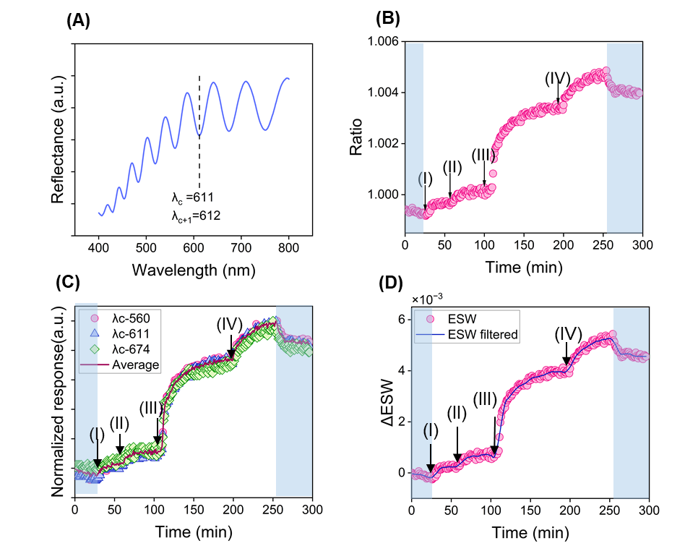
Figure 2. Effective shift in wavelength (ESW) or ratiometric signal processing method for pSiSL Fabry-Pérot biosensors. (A) Representative reflectance spectrum showing the characteristic reflectance minima wavelength identified as λ_{c} = 611 nm and λ_{c+Δλ} = 612 nm; (B) real-time ESW sensogram showing the ratio R(λ_{c})/R(λ_{c+Δλ}) as a function of time during sequential analyte injections at different concentrations (I–IV, 1 µM, 1 µM, 10 µM and 5 µM, respectively), with blue shaded regions indicating PBS buffer steps; (C) normalized response for three different characteristic wavelengths; (D) comparison of raw (unfiltered) and Savitzky-Golay (SG) filtered ESW responses on the same dataset, demonstrating that SG filtering substantially reduces shot noise at the reflectance minima.

Porous silicon multilayer (pSiML) films
The applicability of the ESW method was further evaluated using ML structures, pSi microcavity and Bragg mirror, fabrication details about these is included in the experimental section. Figure 3(A) shows the reflectance spectra (acquired in buffer during insulin sensing using pSiML-APT aptasensor) of a microcavity obtained at three different time points (at 30 min in buffer, and at 50 and 80 min in presence of target analyte) using a near-infrared (NIR) spectrometer with a wavelength resolution of 1.5 nm, which represents the minimum detectable wavelength of the instrument. A magnified view of the resonance dip (characteristic feature of a microcavity) at these three different time points is presented in Figure 3(A)-inset showing a gradual red shift in the spectrum. From 30 min to 50 min, the magnitude of the shift remains below the spectrometer resolution and therefore cannot be reliably quantified using conventional wavelength-tracking methods. In particular, a measurable wavelength shift would only be registered at 80 min once the resonance minimum moves completely to the adjacent wavelength channel, corresponding to a shift of approximately 1.5 nm.
To overcome this limitation, the ESW method was applied to the same dataset. The resulting ratio response is shown in Figure 3(B). Unlike conventional wavelength-shift analysis, the ESW method is capable of resolving subtle spectral changes that occur between two discrete wavelengths. When the wavelength shifts completely to next following wavelength, the ratio signal approaches one. In this framework, a ratio value greater than unity indicates that the spectral feature had shifted sufficiently toward the adjacent wavelength position that can be quantified by the spectrometer. These results demonstrate the ability of the ESW approach to detect sub-resolution spectral shifts that would otherwise be missed using standard peak-tracking techniques. The sensogram in Figure 3(B) shows a clear response to the target analyte dependent on its concentration and follows the expected receptor-analyte binding dynamics from linear increase to approaching saturation.
Moreover, the ESW method was also applied to a Bragg mirror structure, where a reflectance maximum was selected as the characteristic wavelength, as shown in Figure 3(C). Unlike the microcavity resonance dip, the spectral feature of interest in the Bragg mirror is a peak; therefore, the ratio parameter was inverted to generate the sensor response. The resulting ratiometric signal is presented in Figure 3(D), demonstrating that the ESW approach can be readily adapted to both spectral minima and maxima while maintaining sensitivity to subtle spectral shifts.
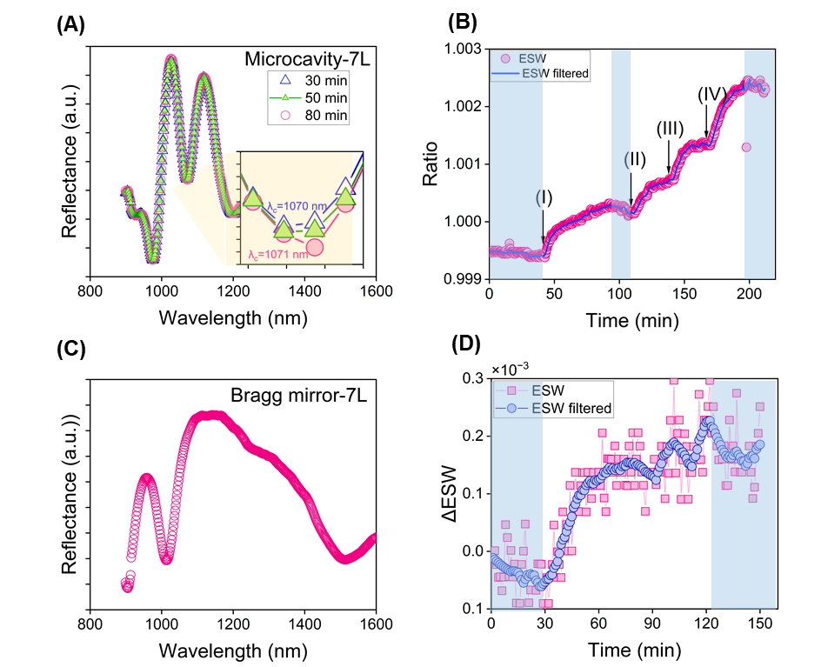
Figure 3. Extension of the ESW method to ML pSi photonic architectures. (A) Microcavity-reflectance spectrum obtained at different time point (data corresponding to 30 min, 50 min and 80 min), inset shows magnified view of the spectra showing the gradual shift in wavelength at these different time points approaching to a shift of 1 wavelength unit equal to the resolution of the spectrometer; (B) real-time ESW sensogram for the microcavity aptasensor during sequential target analyte injections (10 µM, 5 µM, 5 µM and 10 µM) at different concentrations (I–IV), with blue shaded regions indicating PBS buffer wash steps; (C) reflectance spectrum of a Bragg mirror (D) real-time ΔESW sensogram for the Bragg mirror sensor during analyte incubation introduced in the system at 30 min, comparing ESW (pink circles) and SG-filtered ESW (blue squares).

Comparison of ESW with existing computation techniques
In this section, we present a critical comparison of the ESW method with EOT, IAW, and MWP methods. We first compare the stability of the oxidized pSi structures in PBS, followed by in vitro analysis of different biosensor assay comparing baseline drift, sensitivity and selectivity for SL and ML pSi architectures.

pSiSL films
The stability of the oxidized pSiSL films were evaluated in PBS buffer (pH~7.4 similar to a physiological medium). The oxidized pSi was mounted in a plexiglass flow cell, and changes in the reflectance spectrum were monitored under static flow conditions. A stabilization period of about 20 min was allowed before the baseline reflectance spectrum was recorded. The ESW method was implemented in real-time using OceanView or Spectra suite software (Ocean Optics), enabling continuous tracking of the response signal during the experiment. In contrast, all other methods (EOT, MWP, IAW, and ESW-filtered) required post-experiment data collection and offline analysis. The practical advantage of real-time monitoring in lab settings compatible with the existing technology was helpful as transient disturbances such as air bubble introduction could be identified and addressed immediately, rather than being discovered retrospectively during post-processing, a scenario that would otherwise necessitate repeating the experiment.
Figure 4(A) shows the response obtained from the thermally oxidized pSiSL structure in PBS (pH~7.4) buffer using four different data analysis methods. The inset presents the reflectance spectra acquired after 1 and 40 min of incubation in the flow cell. No considerable wavelength shift was observed between the two spectra; however, a small variation in amplitude was evident. Among the four data analysis methods, IAW was particularly sensitive to these small amplitude variations, resulting in signal drift despite the absence of any significant wavelength shift. In contrast, the other three methods exhibited relatively stable response with no significant drift, although differences in their noise levels were observed and quantified as the standard deviation of the normalized response (Figure 4(B)) . Among the methods, EOT exhibited the highest baseline noise while ESW and MWP had comparable noise. Application of SG filtering to ESW further suppressed the baseline noise.
Overall, the results presented in Figure 4 demonstrated that IAW is sensitive to slightest variations in the amplitude of the reflectance spectrum, resulting in baseline drift. While EOT was not affected by amplitude variations but exhibited higher baseline noise. Both MWP and ESW showed effective rejection to amplitude perturbations with no evident baseline drift in buffer and relatively lower noise. Finally, with ESW-filtered this baseline noise is reduced further generating the most stable and reliable performance.
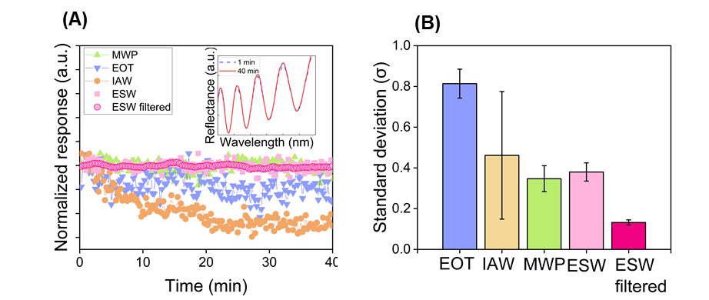
Figure 4. Stability comparison of four signal processing methods applied to oxidized pSiSL in PBS buffer (pH~7.4). (A) Real-time normalized response traces for all four methods (EOT, IAW, MWP, ESW , ESW-filtered) during continuous buffer incubation, inset-reflectance spectra acquired at 1 min and after 40 min of incubation in buffer showing amplitude variation; (B) quantified baseline noise (standard deviation, σ) across replicate sensors for all four methods for N=3.
To evaluate real-time sensing performance, we used P1-pSiSL-APT aptasensor (Figure 5(A(i-iii))). Briefly, the freshly etched pSiSL were oxidized using 1,4-naphthoquinone, coated with a chemical resistant layer of crosslinked Novolac and poly(N,N-dimethylacrylamide-r-acrylic acid) to attach carboxylic acid groups. These were functionalized with maleimide and Trout’s reagent to attach amine modified insulin aptamer (Figure 5(A-iv)). The sensogram obtained for different concentrations of insulin using the various data processing methods is presented in Figure 5(B). The experiment involved first a baseline measurement in buffer and then subsequent addition of different concentrations of insulin at different time points. The standard deviation or the baseline noise was calculated and presented in Figure 5(C). The ESW and EOT had the largest fluctuations as no post-processing was performed. Compared to these, MWP had significantly lower noise as the reflectance spectra were treated to remove white, low and high frequency noise components. The application of SG filtering reduced the fluctuations in the ESW output and hence resulted in the lowest baseline noise. For the sensing experiment, sequential injections of insulin corresponding to time points I-IV in Figure 5(B) were applied in the flow cell (1, 1 10, and 5 µM, respectively). The inset presents the magnified response for low concentration ~ 1 µM and clearly indicates the higher instant response obtained from the ESW-filtered method as compared to gradual response from all other methods. However, at higher concentrations, no significant difference was observed in the response evaluated from all the different computation methods. A linear calibration curve (for N=3) was constructed from the steady-state response, and the LOD was then calculated as,
$$LOD=\frac{3.3σ}{Slope}$$
where σ is the standard deviation of the baseline noise in buffer. The resulting LOD values for all four methods are summarized in Figure 5(D). The ESW method yielded the highest LOD or lowest sensitivity (~670 nM) among all approaches evaluated, which was attributed to its elevated baseline noise at the reflectance minima rather than a reduced sensing signal (the normalized response of ESW in the sensogram closely tracked that of SG-filtered ESW at low insulin concentrations and converged with all other methods at higher concentrations). This confirms that the ratiometric signal carries genuine, concentration-dependent sensing information across the full range, and that the high LOD for ESW reflected the high noise level rather than signal deficiency. Importantly, ESW achieved this with instantaneous, zero-latency signal output, making it particularly valuable for real-time monitoring applications where immediate visual feedback is prioritized over the lowest achievable detection limit. Application of SG filtering to the ESW signal yielded the lowest LOD of all methods (~45 nM), representing a significant improvement over both the unfiltered ESW output and the established EOT, IAW, and MWP approaches. This enhancement can be attributed to higher response signal through sub-pixel interpolation and suppressed shot noise after SG filtering.
The critical and important advantage of the ESW method is the computation time. Figure 5(E) presents the average computation time required to process a single reflectance spectrum for each method, evaluated under controlled conditions: EOT was computed using IGOR Pro software, while IAW, MWP, and ESW-SG were implemented as MATLAB scripts executed sequentially on the same machine to ensure a fair comparison. For ESW, the strip chart function available within Ocean Optics OceanView or Spectra suite software was used to compute and display the ratiometric output for each acquired spectrum instantaneously, requiring no external processing environment. MWP required the highest computational time of all methods evaluated (~615 ms per spectrum), reflecting its multi-step pipeline comprising Fourier transformation, complex Morlet wavelet convolution, phase extraction, and phase unwrapping. ESW-SG required less than 100 ms per spectrum despite the additional filtering step, representing an approximately six-fold reduction in processing time relative to MWP. ESW delivered effectively instantaneous output within the spectrometer software itself, with zero additional computational latency.
We further evaluated the performance of the different computation methods to a protein-A based assay for detection of IgG (pSiSL-PA) using the same SL architecture as in Figure 5(A(i-iii)) but different surface modification. Briefly, the as-fabricated pSiSL was carbonized (THC-pSiSL), and carboxylic acid functional groups were introduced using undecanoic acid and activated with EDC/NHS (Figure 5(F)). Compared to the other measurements, this assay was obtained with a spectra average~10, 10 times lower than usual (100 averages). This was done to evaluate the ESW method under noisy conditions. The EDC-NHS activated pSi biosensor was mounted on plexiglass flow cell. The experiment flow included baseline in buffer, followed by incubation in protein-A (time point (I)), buffers wash, and subsequent injection of different IgG concentrations at time point (II) and (III). The most stable baseline for the buffer wash was obtained for MWP for the complete 10 min period. ESW initially showed a decreasing trend for first few min but later stabilized to similar level as MWP while EOT increased monotonically. In terms of standard deviation, the least variation was seen in MWP followed by ESW, IAW and EOT. After injection of protein-A, which was immobilized on the pSi surface via NHS-functionalization, all four methods showed a linear increasing response approaching saturation at 60 min. However, the response was slightly more pronounced for the ESW method. After a PBS wash to remove unbound protein A (t=70-80 min), IgG was sequentially injected (at 20 µg/mL concentration) at time point (I) and at 500 µg/mL concentration at time point (II). The magnified view of the low-concentration IgG response (t=70-95 min) for 20 µg/mL in the inset shows ESW's superior sensitivity relative to EOT, IAW, and MWP. At 500 µg/mL IgG (injection II), all methods converged toward equivalent responses, consistent with high-concentration dominance of the dispersive sensing channel. ESW consistently produced the highest normalized response across all experimental phases, with the greatest method discrimination observed at the lowest IgG concentration.
It should be noted that the sensogram presented in Figure 5(G) was acquired with a spectral averaging of 10 spectra per measurement, a deliberately reduced averaging condition representative of high-speed real-time acquisition compared to the 100-spectrum averaging used in the baseline noise characterization experiments. This 10-fold reduction in averaging increases the shot noise contribution. Despite this degraded signal averaging condition, ESW unambiguously resolved the low-concentration IgG response at 20 µg/mL (injection II) with clearly superior signal-to-noise ratio relative to all other methods, as shown in the inset of Figure 5(G). This result demonstrates that ESW's sensitivity advantage is maintained even under rapid relatively noisy acquisition conditions.
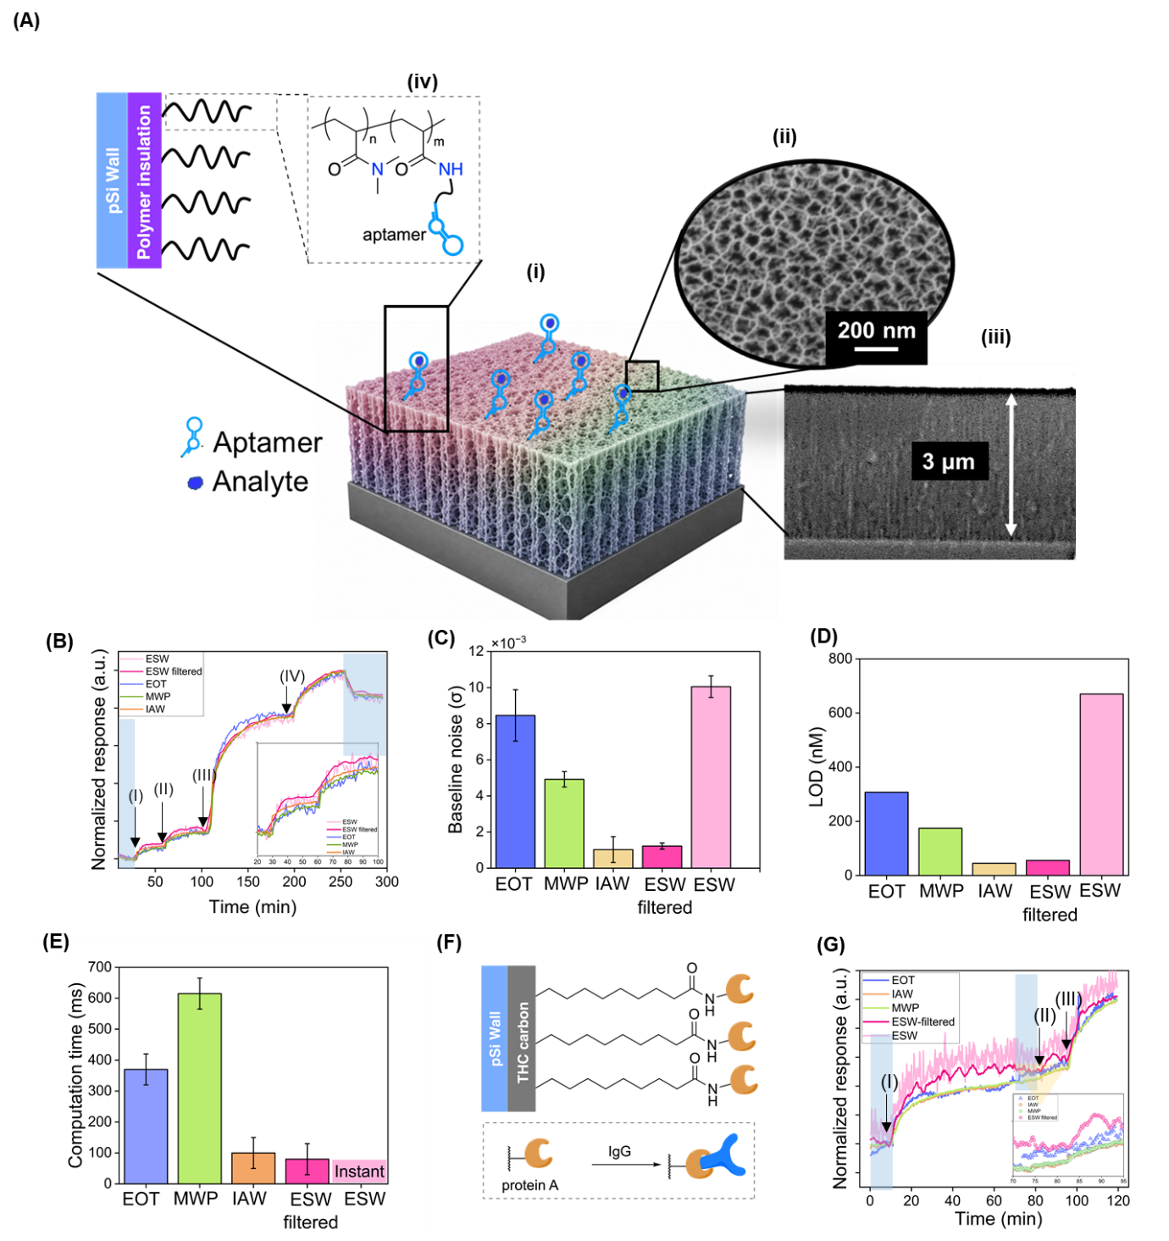
Figure 5. Comprehensive analytical performance benchmarking four signal processing methods on pSiSL biosensors (P1-pSiSL-APT): sensing response, noise, sensitivity, computation time, and multi-analyte detection. (A-i) Schematic of pSiSL architecture with insulin binding to the aptamer (ii) SEM top-view and (iii) SEM cross-section view (iv) immobilization of insulin-binding aptamer on pSi surface; (B) response of the insulin aptasensor evaluated using all four signal processing methods during sequential insulin injections at increasing concentrations (I–IV, refers to the injection of insulin for concentrations 1,1, 10 and 5 µM), with blue shaded regions indicating PBS buffer wash steps; (C) baseline noise (standard deviation, σ) quantified for all four methods from the pre-injection buffer baseline; (D) theoretical LOD calculated from calibration curve of each method for N=3; (E) average computation time per reflectance spectrum for each signal processing method; (F) immobilization of protein-A on pSi surface for detection of IgG;(G) real-time sensogram of pSiSL-PA hierarchical binding assay evaluated using different signal processing methods with reduced spectral averaging (10 spectra per measurement), demonstrating ESW performance under fast-acquisition, high-noise conditions representative of rapid real-time monitoring, (I-III) represents the time point for protein-A (50 µg/mL), IgG 20 µg/mL and 500 µg/mL respectively.

pSiML films
To evaluate the sensing performance of the various data analysis methods to pSiML architecture, we used pSiML-APT aptasensor (Figure 6(A(i-iii)). Briefly, pSiML microcavity structures were thermally oxidized at 800 ˚C, followed by salinization to attach amine groups. The amine modified insulin aptamer was then immobilized using glutaraldehyde linker (Figure 6(A(iv))).
The baseline stability of the pSiML structures in PBS buffer (pS~7.4) under static flow in a Plexiglas flow cell was evaluated using IAW, MWP, ESW and ESW-filtered data processing methods (Figure 6(B)). Application of EOT to pSiML architectures is fundamentally limited by the spectral complexity of these structures. The EOT method when applied to pSiML microcavity biosensor generated continuous large-amplitude excursion (Figure S3 in supporting information) and hence was not included in the comparative studies here. IAW and MWP both exhibited pronounced baseline drift throughout the measurement period while ESW and ESW-filtered generated a relatively stable response. Comparison of the reflectance spectrum at different time points during the measurement period showed no visible wavelength shift but a small amplitude variation (Figure S4). The observed drift in the IAW response arises from this amplitude variation.
Next, we compared the sensograms obtained for insulin detection for low (Figure 6(C)) and high concentration of insulin (Figure 6(D)). For low concentration ~1 μM, the ESW method produced a large, rapidly developing response upon insulin introduction, with clear signal attenuation during PBS wash step (Figure 6(C)). In contrast, both IAW and MWP exhibited monotonically increasing signals throughout the experiment including incubation in PBS during baseline measurement and subsequently after introducing insulin. This drift behavior precludes reliable attribution of IAW and MWP responses to specific insulin binding on the ML architecture. ESW was therefore the only method capable of generating a clearly interpretable sensogram on the pSiML demonstrating a unique structural versatility that distinguishes it from all existing signal processing approaches including MWP, which is the current state-of-the-art for SL pSi biosensors. For high concentration (15 µM), similar to SL, all the methods produced a similar response.
The selectivity of the pSiML aptasensor was evaluated by sequential exposure to three non-target analytes — glucose (5 mM), IgG (5 µM), and BSA (5 µM) followed by specific insulin injections at 1 µM (injection I, t≈80 min) and 5 µM (injection II, t~110 min), with all signal processing methods applied simultaneously to the acquired reflectance data (Figure 6(E)). IAW exhibited a monotonically increasing drift that persisted regardless of analyte identity indistinguishable between buffer, non-specific analytes, and specific insulin precluding any meaningful signal interpretation on this architecture. Both MWP and ESW showed no binding response upon sequential exposure to glucose, IgG, and BSA, indicating that these non-target analytes do not bind to the aptamer. Upon introduction of 1 µM insulin at t≈80 min, however, the two methods diverged critically: MWP showed no detectable change in the response curve whereas the ESW method responded immediately with an increasing signal, suggesting an increase in the effective refractive index of the pSi layer upon binding of the insulin to the aptamer. The ESW signal rose steadily before plateauing. Upon the second insulin injection at 5 µM (injection II, t≈110 min), MWP showed only a gradual and marginal positive response detecting the specific target analyte gradually at a concentration 5-fold higher than that detected by ESW. ESW again responded immediately with a clear, rapid increase that plateaued over time, consistent with additional aptamer-insulin binding at higher analyte concentration. The superior performance of ESW over MWP for pSiML structures can be attributed to the different spectral regions that each method was applied. MWP was evaluated across the entire wavelength range of the microcavity reflectance spectrum while ESW was specifically applied to the microcavity characteristic or resonance wavelength that detects the subtle changes in the reflectance spectrum.
These results demonstrate that for pSiML microcavity photonic structures, ESW substantially outperforms all existing signal processing methods uniquely providing immediate, unambiguous discrimination between non-specific and specific analytes with high signal-to-noise ratio where MWP, EOT, and IAW all fail to provide interpretable sensing signals.
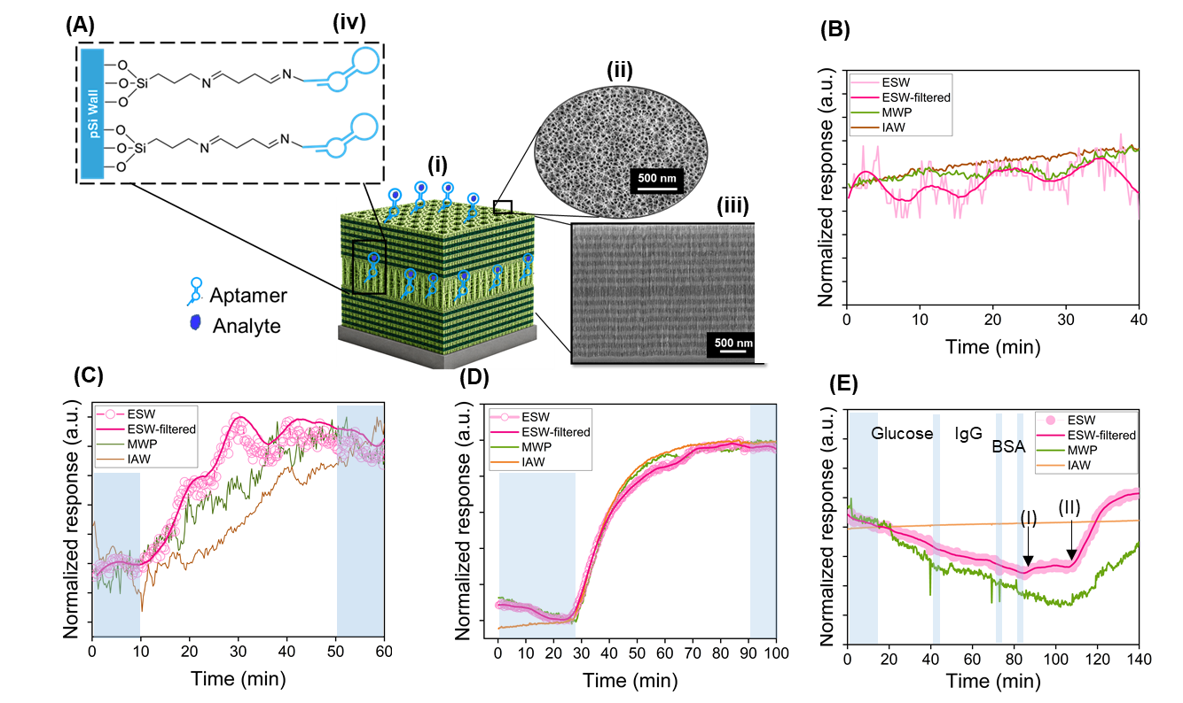
Figure 6. Performance comparison of IAW, MWP, and ESW signal processing methods on pSiML photonic biosensors (pSiML-APT aptasensor). (A) pSiML microcavity (i) showing 7L architecture (ii) SEM top-view and (iii) SEM cross-section view (iv) immobilization of insulin binding aptamer on pSiML surface; (B) stability of the designed biosensor in buffer; sensograms for detection of insulin (C) low concentration (1 μM) ; (D) high concentration (15 μM); (E) response to non-specific analytes glucose (5 mM), IgG (5 µM), and BSA (5 µM) followed by specific insulin injections at 1 µM (I) and 5 µM (II), with blue shaded regions indicating PBS buffer steps.

Sensor performance in complex media
The reflectance spectra (acquired at different time points in buffer and serum) and corresponding normalized response over time for all four signal processing methods to neat human serum both on oxidized and antifouling layer (P1-pSiSL) coated pSiSL structures are presented in Figure 7(A-D). In each experiment, a baseline in buffer was established prior to serum introduction, followed by a final buffer wash to assess reversibility. The two surfaces exhibited different spectral behavior upon serum exposure. On the oxidized surface, serum introduction produced a dominant shift in wavelength in the reflectance spectrum with no significant change in fringe amplitude or spectral offset (Figure 7(A)). On the antifouling layer-coated surface, serum exposure produced a pronounced downward signal offset in the reflectance spectrum accompanied by a reduction in signal amplitude (Figure 7(B)). These variations in the wavelength, amplitude and signal offset were captured by all four methods in different ways. In the absence of substantial and sustained changes in interference amplitude or signal offset, ESW, ESW-filtered, MWP, IAW and EOT exhibited similar response with only IAW exhibiting an overshoot just after introducing serum in the flow cell ((Figure 7(C)). This overshoot can be attributed to the temporary change in the reflectance amplitude (Figure S5). As the interference amplitude stabilized, the IAW response progressively approached the response obtained using the other methods (Figure 7(C)). In the presence of continuous amplitude and offset variations (Figure 7(B)), IAW and EOT diverged significantly from MWP and ESW. IAW and EOT showed abrupt signal increase while MWP and ESW showed gradual increase (Figure 7(D)). This behavior can be attributed to additive effect of bulk refractive index change and artefacts arising from the downward signal offset observed in the reflectance spectrum. While MWP rejects these artefacts with a complex noise filtering technique, ESW inherently does so by the ratiometric operation at adjacent reflectance minima. This approach cancels any common-mode amplitude and offset changes that affect both minimum wavelengths equally, since these slowly varying spectral perturbations change negligibly over the small wavelength interval separating adjacent minima. Consequently, reliable and accurate characterization of antifouling coating performance in complex undiluted biological media where spectral offset and amplitude perturbations are inherently pronounced can only be achieved using the MWP or ESW methods for pSiSL structures. It is important to note here that MWP did so at the cost of higher computation time and complex infrastructure as compared to the ESW method.
Further, all the four methods were tested for a more complex situation where the pSiML biosensor functionalized with insulin aptamer was subcutaneously implanted in a cadaver mouse (Figure 7(E), EOT method was very noisy and unreliable, hence, not included here). The reflectance spectrum was recorded after 30 min of implantation. Initially, for the first 15 min, IAW showed continuous increase while MWP and ESW looked relatively stable. After subcutaneously injecting insulin in ISF, the ESW method produced a clear, sustained positive response beginning immediately upon insulin injection and rising continuously and gradually plateauing. IAW showed a moderate positive response following insulin injection; however, given IAW's established susceptibility to amplitude and offset variations on the ML microcavity architecture which are substantially amplified in the complex and continuously evolving optical environment of subcutaneous tissue its response cannot be unambiguously attributed to specific insulin binding. The MWP method after insulin injection showed similar behavior to ESW, but a downward drift manifested after 5 min. Notably, MWP operates over the entire spectrum and captures the relative shift across it while ESW only concentrates on the microcavity resonance wavelength.
Overall, the comparative analysis of EOT, IAW, MWP, ESW, and filtered ESW across the critical performance parameters is summarized in Table 1. The results demonstrate the robustness of the ESW method against amplitude and signal offset variations, enabling its application across different pSi architectures with reliable performance in complex media. Although ESW exhibits relatively higher baseline noise, this does not compromise its ability to resolve the analytical response, even at the lowest analyte concentration investigated. Furthermore, the baseline noise can be effectively reduced through SG filtering but at the expense of increased computational time. Nevertheless, the computational cost of filtered ESW remains lower than that of the other evaluated methods.
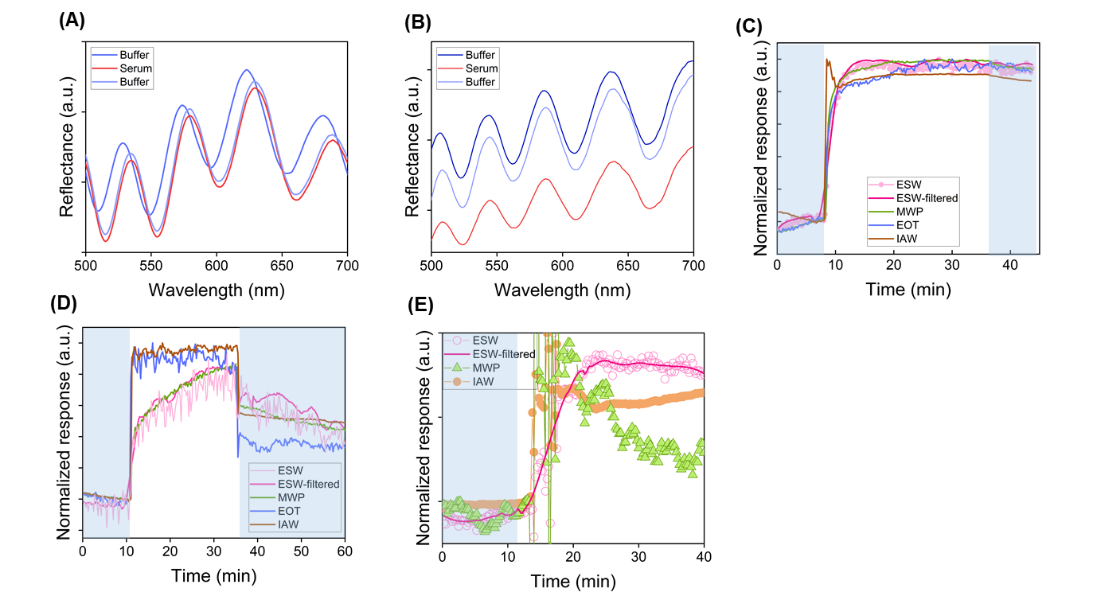
Figure 7. Performance of ESW, MWP, EOT, and IAW signal processing methods in complex biological environments. Reflectance spectrum acquired in buffer and serum for (A) oxidized pSiSL predominantly showing shift in wavelength upon exposure to neat human serum; (B) antifouling coated P1-pSiSL showing signal offset and amplitude variation upon exposure to neat human serum; Real-time normalized response of four signal processing methods during exposure to undiluted human neat serum (white region) with PBS baseline and wash steps (blue shaded regions) (C) oxidized pSiSL (D) antifouling coated P1-pSiSL; (E) real-time optical response of ESW, MWP, and IAW during subcutaneous insulin injection (t≈15 min, white region) into ex vivo mouse containing an implanted aptamer-functionalized pSiML sensor (pSiML-APT aptasensor), with blue shaded region indicating the pre-injection baseline period.
Table 1. Comparison of different data processing methods.(Green-good, Yellow-fine, Red-Poor)
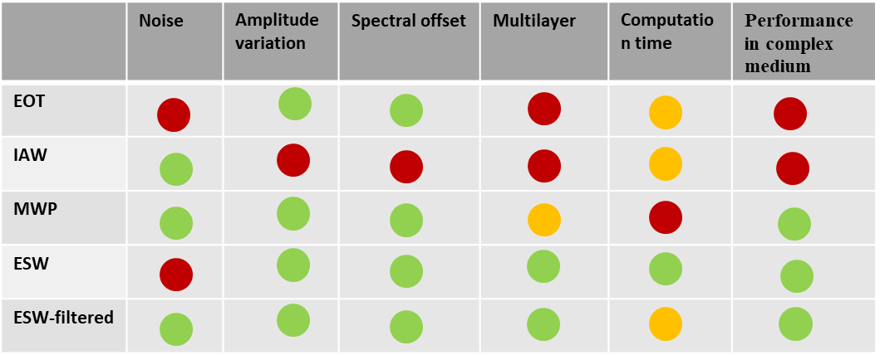

CONCLUSION
In summary, this work introduces the effective shift in wavelength (ESW) method as a computationally minimal, architecturally versatile, and analytically competitive signal processing approach for pSi optical biosensors — and presents its first systematic benchmarking against three established methods, RIFTS/EOT, IAW, and MWP, across different performance metrics: analytical sensitivity, baseline noise, selectivity, computation time, applicability to both single-layer Fabry-Pérot and multilayer photonic architectures, performance in complex biological matrices, and validation as an implantable biosensing platform.
On pSiSL structures, ESW with Savitzky-Golay filtering achieved the lowest LOD among all methods evaluated with the lowest computational overhead, requiring only two spectral intensity values and a single arithmetic operation. Baseline noise characterization revealed systematic drift in EOT and continuous monotonic drift in IAW, both attributable to their sensitivity to amplitude and offset perturbations, while MWP and ESW produced comparably stable baselines, with ESW-filtered achieving the lowest baseline noise of all methods.
Extension of the ESW method to pSiML architectures established it as the superior signal processing approach for these complex photonic structures. EOT produced physically uninterpretable signal excursions arising from Fourier peak ambiguity when multiple superimposed frequency components coexist in the multilayer transform, rendering it unsuitable for pSiML biosensing. IAW, though Fourier-independent and fundamentally applicable to multilayer architectures, provided physically non-selective output that conflated true wavelength shifts with amplitude and offset perturbations. MWP yielded meaningful sensing response, but was less sensitive compared to the ESW method owing to its inherent application to broad spectral window.
Performance in neat human serum revealed a fundamental divergence between methods. Simultaneous offset, amplitude, and fringe shift perturbations introduced by the biological matrix produced large artefactual responses in EOT and IAW, neither method capable of separating genuine adsorption signal from matrix contributions. In contrast, MWP and ESW retained physically interpretable responses throughout serum exposure and buffer washing, establishing both as prerequisites for reliable biosensor characterization in undiluted biological fluids. As an implantable biosensor, ESW maintained physically interpretable responses under the continuous uncontrolled spectral perturbations characteristic of ex vivo optical environments
Collectively, ESW addresses the complete set of practical requirements for clinical translation of pSi-based optical biosensors delivering competitive LOD, superior long-term stability, real-time native output, and unique ML applicability through a single computationally minimal ratiometric operation. This represents a practically complete signal processing solution for next-generation implantable and POC pSi biosensing platforms.

Acknowledgements
This work was performed at the Melbourne Centre for Nanofabrication (MCN) in the Victorian Node of the Australian National Fabrication Facility (ANFF). N.H.V. acknowledges support from the Australian Research Council Laureate Fellowship scheme (FL220100185).

REFERENCES
[1] Y. Wu, K.W. Plaxco, On the Design, Fabrication, and Operation of Electrochemical Aptamer-Based Sensors, ACS Sens. 10 (2025). https://doi.org/10.1021/acssensors.4c03465.
[2] K. Li, R. Gupta, A. Drayton, I. Barth, D. Conteduca, C. Reardon, K. Dholakia, T.F. Krauss, Extended Kalman Filtering Projection Method to Reduce the 3σ Noise Value of Optical Biosensors, ACS Sens. 5 (2020). https://doi.org/10.1021/acssensors.0c01484.
[3] A. Savitzky, M.J.E. Golay, Smoothing and Differentiation of Data by Simplified Least Squares Procedures, Anal. Chem. 36 (1964). https://doi.org/10.1021/ac60214a047.
[4] F. Cui, Y. Yue, Y. Zhang, Z. Zhang, H.S. Zhou, Advancing Biosensors with Machine Learning, ACS Sens. 5 (2020). https://doi.org/10.1021/acssensors.0c01424.
[5] R. Sánchez-Salcedo, P. Sharma, N.H. Voelcker, Advancements in Porous Silicon Biosensors for Point of Care, Wearable, and Implantable Applications, ACS Appl. Mater. Interfaces 17 (2025) 2814–2843. https://doi.org/10.1021/acsami.4c18273.
[6] H. Zhou, J. Guo, Z. Wang, J. Zhao, Z. Gao, P. Song, Y.Y. Song, C. Zhao, Enzyme-Free Identification of Monosaccharide Enantiomers on TiO2 Nanotube Array-Based Fabry-Pérot Interferometer, Anal. Chem. 96 (2024). https://doi.org/10.1021/acs.analchem.4c04160.
[7] G. Rajeev, E. Xifre-Perez, B. Prieto Simon, A.J. Cowin, L.F. Marsal, N.H. Voelcker, A label-free optical biosensor based on nanoporous anodic alumina for tumour necrosis factor-alpha detection in chronic wounds, Sens. Actuators B Chem. 257 (2018). https://doi.org/10.1016/j.snb.2017.10.156.
[8] X. Jiang, R. Fishler, G. Ron, K. Boguslavsky, S. Halachmi, E. Segal, Integrated iPRISM Direct-on-Urine Platform for Rapid UTI Diagnosis in a Double-Blind Clinical Trial, ACS Measurement Science Au 6 (2026) 454–465. https://doi.org/10.1021/acsmeasuresciau.5c00187.
[9] R. Chhasatia, M.J. Sweetman, F.J. Harding, M. Waibel, T. Kay, H. Thomas, T. Loudovaris, N.H. Voelcker, Non-invasive, in vitro analysis of islet insulin production enabled by an optical porous silicon biosensor, Biosens. Bioelectron. 91 (2017) 515–522. https://doi.org/10.1016/j.bios.2017.01.004.
[10] K.P.S. Dancil, D.P. Greiner, M.J. Sailor, A porous silicon optical biosensor: Detection of reversible binding of IgG to a protein A-modified surface, J. Am. Chem. Soc. 121 (1999) 7925–7930. https://doi.org/10.1021/ja991421n.
[11] S.J. Ward, R. Layouni, S. Arshavsky-Graham, E. Segal, S.M. Weiss, Morlet Wavelet Filtering and Phase Analysis to Reduce the Limit of Detection for Thin Film Optical Biosensors, ACS Sens. 6 (2021) 2967–2978. https://doi.org/10.1021/acssensors.1c00787.
[12] S. Mariani, L.M. Strambini, G. Barillaro, Femtomole Detection of Proteins Using a Label-Free Nanostructured Porous Silicon Interferometer for Perspective Ultrasensitive Biosensing, Anal. Chem. 88 (2016) 8502–8509. https://doi.org/10.1021/acs.analchem.6b01228.
[13] S. Mariani, L. Pino, L.M. Strambini, L. Tedeschi, G. Barillaro, 10 000-Fold Improvement in Protein Detection Using Nanostructured Porous Silicon Interferometric Aptasensors, ACS Sens. 1 (2016) 1471–1479. https://doi.org/10.1021/acssensors.6b00634.
[14] R. Chhasatia, M.J. Sweetman, B. Prieto-Simon, N.H. Voelcker, Performance optimisation of porous silicon rugate filter biosensor for the detection of insulin, Sens. Actuators B Chem. 273 (2018) 1313–1322. https://doi.org/10.1016/j.snb.2018.07.021.
[15] P. Sharma, J. Harberts, R. Sánchez‐Salcedo, P. Dehghankelishadi, N.H. Voelcker, Implantable, Label‐Free NIR‐Based Porous Silicon Biosensor for Monitoring Biomarkers in Interstitial Fluid, Advanced Sensor Research (2025). https://doi.org/10.1002/adsr.202500007.
[16] N.H. Voelcker, I. Alfonso, M.R. Ghadiri, Catalyzed oxidative corrosion of porous silicon used as an optical transducer for ligand-receptor interactions, ChemBioChem 9 (2008). https://doi.org/10.1002/cbic.200800119.

